COMPUTER GRAPHICS AUTOCAD PRACTICAL

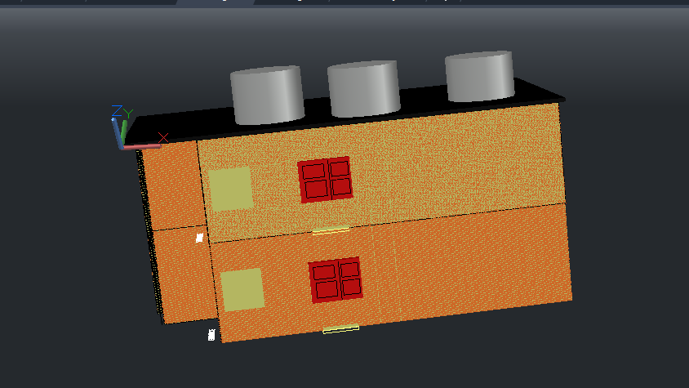

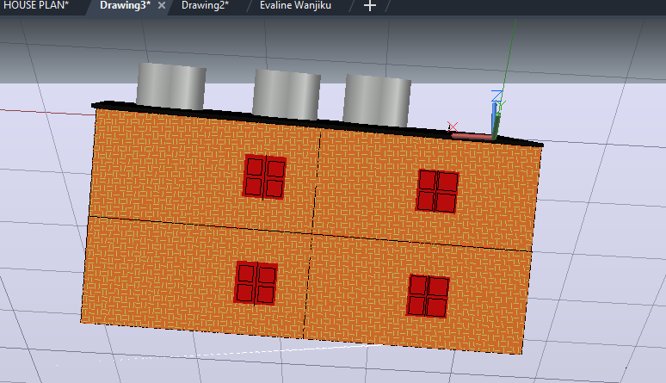

Above are the photos sourced directly from my autocad drawing

Floor Plan Design

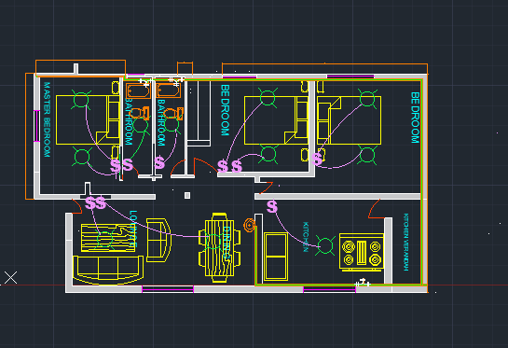
a)Walls
- The layout features defined external and internal partitions to create a clear separation between common and private zones.
- The walls have been hatched and added a solid hatch in them
- We went on and used the offset command on the walls inorder to create the space in between with a length of 1 mm
b)Doors & Windows
- Openings are systematically placed, with dedicated layers for doors which have a red color and windows have been given the color purple to ensure visibility during the drafting process.
c)Room Layout
- Social Zone
It Includes a spacious Lounge and Dining area located at the front of the unit.
- Service Zone
Features a Kitchen with an attached Kitchen Verandah for utility access.
- Private Zone
It includes a Master Bedroom with an ensuite bathroom, plus two additional Bedrooms.
- Washrooms
Two bathrooms are centrally clustered to serve both the residents and guests efficiently.

d) Layer Management & Line TypeThe house has a number of layers which consist of the following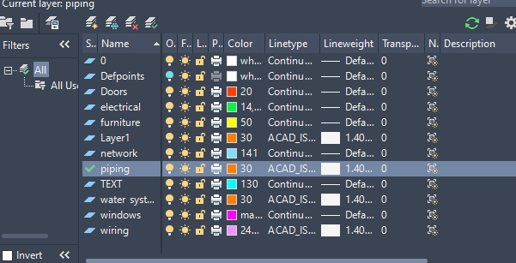

Labels
Each functional area of the floor plan is clearly labeled to define spatial use and circulation flow:
- Private Zone: Includes the MASTER BEDROOM, BEDROOM 2, and BEDROOM 3.
- Social Zone: Features a large LOUNGE and a dedicated DINING area.
- Service/Utility Zone: Designated areas for KITCHEN, KITCHEN VERANDAH, and two separate BATHROOM units.

Technical Legend Symbols
The legend section provides a standardized shorthand for Mechanical, Electrical, and Plumbing installations, ensuring accurate interpretation by contractors
ELECTRICAL WIRING LAYOUT
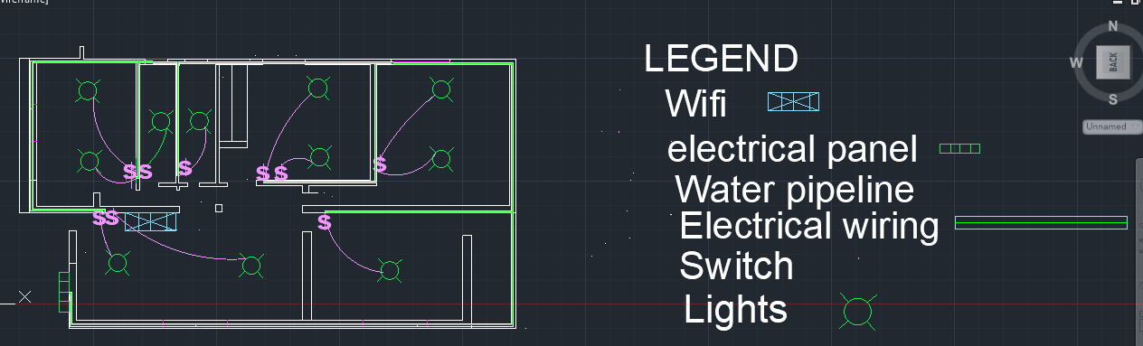
- Main Power Supply:
The power entry and main conduits are managed on the wiring layer. This layer uses a specific linetype and a heavy lineweight to ensure primary power paths are visually distinct from structural elements.
- Distribution Panel
The Distribution Panel is represented by a green segmented box symbol and is strategically placed near the Lounge/Entrance for centralized control. This component is managed on the electrical layer (Green, Index 14).

Lighting points and socket outlet
The plan utilizes a specific symbolic language to denote control points and illumination sources.
- Socket outlet
Manual controls are represented by the $ dollar Sign symbol in purple.
Single Gang (S): Located in the Kitchen and smaller bedrooms.
Double Gang (SS): Positioned at the entry of the Lounge and Master Bedroom to control multiple lighting groups from a single point.
- Lighting Points
Illumination points are indicated by a Green Circle with a Cross symbol. These are distributed to ensure uniform lux levels:
Lounge: 4-point distribution.
Master Bedroom: 3-point distribution.
Kitchen/Dining: Targeted lighting for task areas.

Legend & Symbols
To facilitate accurate installation, the following standardized symbols are defined:
Switch$ / $$ Wall-mounted manual controls
Lights (Green)electricalCeiling-mounted illumination points
Electrical Panel[ Green

WATER SUPPLY AND PLUMBING SYSTEM
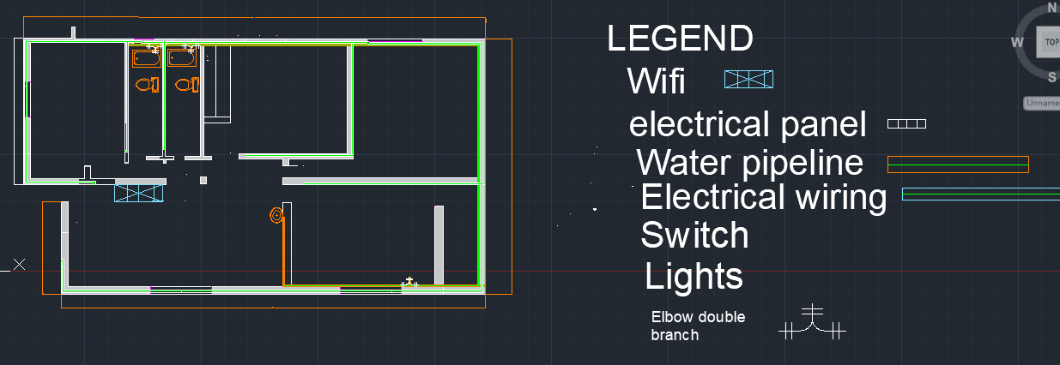

Main Water Inlet
The entry point for the house is positioned to feed the perimeter distribution lines.
Water Tanks
The 3D model identifies roof-mounted storage cylinders to provide necessary head pressure for the fixtures.
Horizontal Distribution
The Water Pipeline coded in orange circumnavigates the building's exterior and interior walls to serve "wet" zones.
Vertical Risers
Internal connections allow for the vertical transfer of water from the roof tanks to the floor-level distribution pipes.

Washroom and Kitchen Connections
The plan employs a Wet-Core strategy, clustering all high-consumption areas for efficient material use.

- Bathroom Units
Directly served by the orange pipeline, providing supply to toilets and showers.
- Kitchen/Laundry
The pipeline extends to the kitchen and kitchen verandah to support food preparation and utility needs.
- Fittings
Specialized connections, such as the Elbow double branch, are utilized at pipe intersections to maintain flow velocity and pressure.
Water Tanks
The water storage system is designed as a rooftop installation to leverage gravity for internal distribution.
- Unit Quantity
The 3D model identifies two (2) high-capacity cylindrical tanks positioned on the building's roof.
- Placement
The tanks are centrally located above the "wet-core" area bathrooms/kitchen to minimize pipe travel and pressure loss.
Correct plumbing symbols and pipe routing

Standardized Plumbing Symbols
The drawing utilizes a clear Legend to define the mechanical components, ensuring that the design is easily interpreted by contractors.
- Water Pipeline
Represented as a double-line orange path, used to indicate the primary horizontal supply routes throughout the building.
- Elbow Double Branch
A specific icon is used to denote multi-directional pipe fittings, ensuring that intersections are technically accurate for fluid dynamics.

- Water Tanks
Represented as cylindrical masses in the 3D model, these symbolize the primary storage and gravity-pressure source for the system.
- Sanitary Fixtures
Specific symbols for toilets and bathtubs are used within the washrooms to mark final connection points.

2. Pipe Routing Strategy
The routing logic follows a Wet-Core centralization to maximize efficiency and minimize material waste.
- Main Distribution Path
The orange pipeline follows the perimeter and internal partitions, ensuring direct access to the Kitchen, Kitchen Verandah, and both bathrooms.
- Horizontal Routing
All horizontal pipes are aligned with wall segments, which are drafted specific dimensions for both internal and external partitions to accommodate the piping diameter.
- Vertical Integration:
The routing accounts for vertical risers that connect the rooftop Water Tanks to the floor-level distribution network.

WI-FI AND NETWORK CABLING REPORT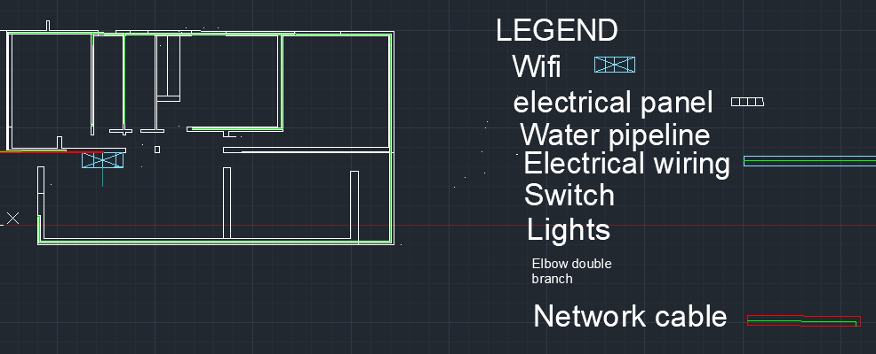

Network Backbone and Data Routing
The digital infrastructure is designed to provide high-speed connectivity through a structured cabling approach.
- Network Backbone
The primary data entry point is integrated into the central service corridor, managed on the network layer.
- Data Cabling Routes
High-speed conduits are routed from the main entry point to specific data drops. These routes are distinguished by the Light Blue continuous line to differentiate them from power and plumbing systems.

Hardware Distribution & Access Points
The layout ensures total signal coverage across all habitable rooms.
- Wi-Fi Access Point (AP) Locations
A centralized Wi-Fi AP is positioned in the Lounge/Dining area to maximize line-of-sight coverage for the living areas and adjacent bedrooms.
- Distribution Switches
The network hub is co-located near the Electrical Panel in the lounge area for ease of maintenance and shared conduit use.
- Room Connectivity:
Dedicated data drops are provided for the Master Bedroom and Lounge to support high-bandwidth devices

